Economic and Lead Generation Model
SET FISCAL YEAR ECONOMIC GOAL YEAR: ____________
Want to EARN $ ______________________
Need/Must EARN $____________________
- Difference is $_______________________

Exercise: What would I do with the difference?
_______________________________________________________________
_______________________________________________________________
_______________________________________________________________
_______________________________________________________________
Homework – VISION BOARD IT OUT

Exercise: Read and Ponder
As a new season beckons, most of us have been doing our usual review of the last year and re-reading our journals, looking back at old goals as well as planning ahead. Most agents are “ok” or “complacent” with their achievement, yet would like more. The Rolling Stones famously sang, “You can’t always get what you want, but if you try sometimes, you just might find… you get what you need.” Desire is important – in fact, it’s the basis and foundation of all achievement – it serves as the fuel and motivation to push us forward to live the lives we want. No one can create motivation for you. It comes from within. In that sense, it is an essential component of a happy and fulfilling life. Yet, the problem can lie in the essence of our desire. It would appear the reason most of us get what we need, and not what we want, is that what we want isn’t tied deeply enough to our hearts. So the questions to ask are… “Why do I want what I want?” “What is important about what I want?” “How will I feel when I get what I want?”
Once “What we Want” is tied to a REALLY BIG REASON DEEPLY ROOTED IN OUR HEARTS – the kind of reason where failure is not an option – we get it. What’s your reason?

ECONOMIC AND LEAD GENERATION MODEL – WORKING FARM, NETWORKING & COI

Average Transaction Price is $______________ currently. If your average transaction price is less than that, you’re working below the market and you’ll need to do more transactions to make your goal! Hint: Keep your market mix flexible and diverse in these economic times.
FARM AREA DETERMINATION
My FARM area/NICHE is: _______________________________________________________
HOMEWORK: IF YOU DO NOT HAVE A FARM OR IF YOUR FARM ISN’T PRODUCING AT LEAST 20% OF YOUR BUSINESS:
Do the fishing pond exercise: We want to see a market with at least 60 Closed Deals (5/month) in the last year & 60 On the Market Active NOW
Avg. Price Point of closed business there is $____________________? Does that work? _____
ACTION STEPS TO INCREASE CUSTOMER BASE – BUSINESS IS ALL AROUND YOU!
- HOW’S THE MARKET SCRIPT
- CENTER OF INFLUENCE SCRIPT
Hint: Get customer information. Always come from a point of contribution/assistance.

Exercise: SCRIPT PARTNER PRACTICE – 20 minutes

The RULES of Role Play
- The goal is to get through the script simply by reading it and becoming familiar.
- The customer should be agreeable and realistic, not antagonistic.
- No chatting during Role Play – it’s time to practice!
- Move quickly through the script and switch so your partner has time to practice.

How’s the Market Script

<<How’s the market?>> or, <<we hear the market is improving>>
GREAT/YES! Actually, ________ (name), right now I’m looking for homes to sell. WHO do you know looking to buy or sell that could use my help?
<<Well my mom may be looking to buy this summer.>>
Good for (name) – it’s an excellent time to be a buyer here. So, how could I reach her/him to introduce myself and see how I can help?
<<why don’t you give me your card and I’ll have her call you.>>
I could give you my card, sure! At the same time, I wouldn’t want her to get frustrated trying to reach me… I’m a serious agent and usually with customers. So what’s the best number to reach her?
OR
<<no, I don’t know of anyone>>
Got it. So, where do you live? <<Bonita Bay>> Nice! How long have you been there? <<5 years>> Perfect. So, _________ (name) WHO keeps you informed on what’s happening in (development) and the values there? <<no-one>> Wow! I’d be happy to have my team keep you up-to-date on sales there and what your property is worth. What’s your email? <<email>>
And, while we’re together… I’ll give you my personal cell number. Most of my customers find it easy just to put me in their phone under “Realtor®.” That way, they don’t have to remember my name or go searching for my card. (give your REALTOR® name/cell/company and have them put it in their PHONE).

Hint: There’s a way to get them to ask you what you do for a living…. ask what they do, or compliment them on their job performance if it’s appropriate, then simply say, “I really like my work too!” Then BE QUIET!

Center of Influence Script

Hi ________, this is ________________ from_____________ (how you know them)…How are you? <<just fine>>. This is really a quick business call … do you have a minute? <<yes>> As you may know, I’m in real estate here in Southwest Florida with a top team… and I’ve recently come across a fantastic buying opportunity. <<oh really?>>
Yes! You know it’s still such an exciting time to be a buyer here! (pause, then describe one of the properties a bit)
This is a 2-bedroom, 2-bath, golf course community with a lake view… listed about 10% under appraisal, even if someone bought it and rented it out – it could be a great opportunity.
And I’m calling to see…. WHO you know that may want to get in on this, either to use or for rental income? <<no-one, but I’ll call you if I think of someone>> Thank you, and I know I’ve caught you off guard with this.
So I know sometimes once this… sinks in… you may think of someone days later that would want a place in paradise… so what I will do is email you a copy of the property virtual tour which is fun to watch, along with my contact information – and you can forward it along to anyone you think of, ok? <<yep, fine>>

Great… I’ll call you back sometime when we can catch up more.

OR

<<YES, as a matter of fact my cousin has been looking down your way>>
Good for (name) – it’s an excellent time to be a buyer here. So, how could I reach her/him to introduce myself and see how I can help? << here’s the number>>
Thank you! Is it ok to mention your name, or should I keep it confidential?
<<you can say I gave it to you>>
OK, will do. I will give you a call back when we can catch up socially. Give my best to (wife/family).

*Hint: Send just the virtual tour link with your contact information and a short note…. “Great talking with you!”

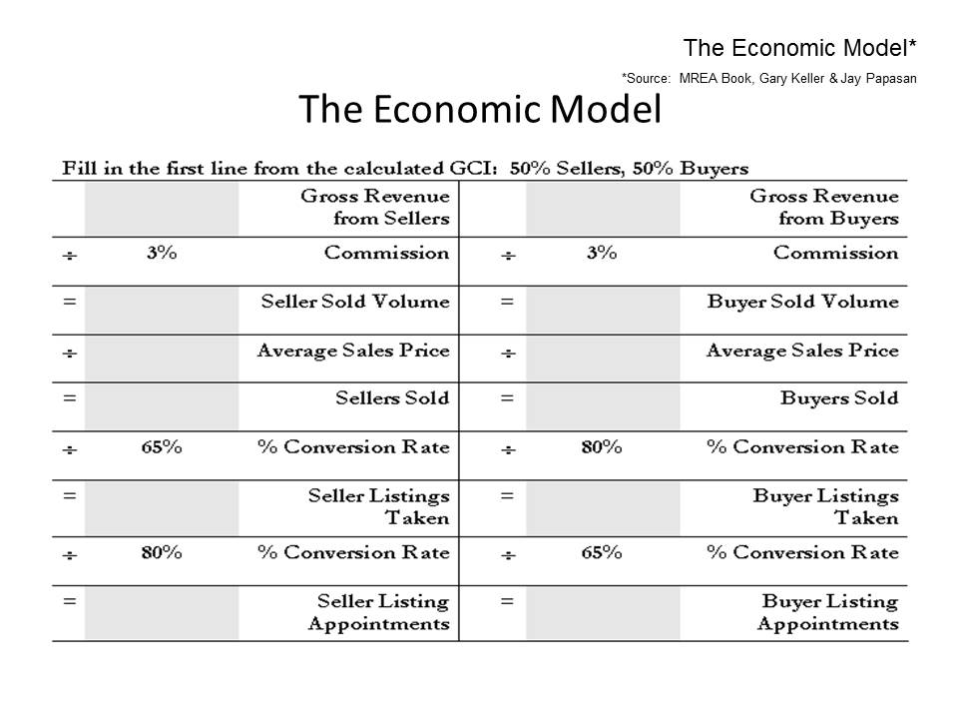

80%
65%

80%
65%

/ 9 = Buyer Listing
Appointments/Month

App
/ 9 = Seller Listing
Appointments/Month

App

THE LEAD GENERATION MODEL

$____________________ sales volume goal by ___________________ (one year from now)

$ NET Income ________________ = _________________transactions @ $______________ price point
- COI/Past Clients/Ref
- Open Houses
- Your LISTINGS!

_____ Seller listings closed ____ buyers listings closed - Source

Seller Listings taken ________ (In place by ___________________)

_______ Seller Listing Appointments

- Expireds

- Terminateds

- FSBOs

1x11______ people talk to SELLERS – Who are they?

1x13______________ calls = ____________ calls/day

(DIVIDE by 160 DAYS)

Exercise: Review MREA Focus Paragraph Page 298

